 |  | 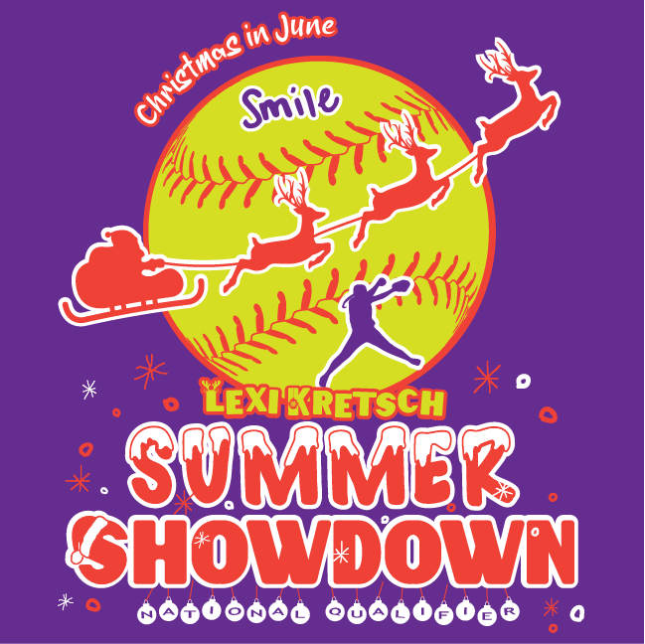  Lexi Kretsch Summer Showdown Scholarship Application

Name

Billing address

City, ST Zip Code

Phone | Cell

Email

Team Name you are playing with in the tournament

Name of college you will be attending

Requirements: Must be a 2023 High School Graduate, playing on a team registered for the Lexi Kretsch Summer Showdown. Deadline for submittal is June 1, 2023. The Scholarships will be awarded at the tournament. This year we may give up to 6 Scholarships.

On a separate page, please write/type an essay explaining what life lessons playing softball has taught you. Can be a paragraph long but no more than a page long.

This scholarship is being provided through the Lexi Kretsch Summer Showdown Scholarship Fund administered by MN Vortex/MN A’s. The scholarships are in memory of Lexi, an amazing softball player and even more amazing young woman. Lexi’s passion for life was to make a positive difference in the lives of others, make others feel loved through her contagious laugh and beautiful smile and give forward as she did by being an organ donor and saving a man’s life. Providing these scholarships will continue her legacy of giving forward. This year we may give up to 6 Scholarships. Thank you for applying.

Email or Mail Completed Scholarship Application Form to: teamkretsch@gmail.com
Jennifer Kretsch
1707 Fountain Lane
Waconia, MN 55387

I will contact you with a confirmation that I have received your application. If you do not hear from me, please contact me at 507-276-5493. It is the policy of this organization to provide equal opportunities without regard to race, color, religion, national origin, gender, sexual preference, age, or disability.

